# Adding ARKs to SKCA Records

Search for the record in the Catalog Module.

Click Catalog, Edit Catalog Records.

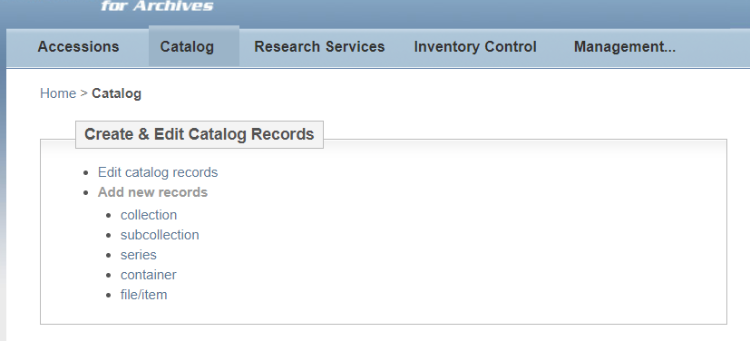

The easiest way to find the record is to search by Repository Number. Enter the collection number here (For Manuscript Collections, MS-0000; for University Archives: RS-00-00-00). Click Search & Display.

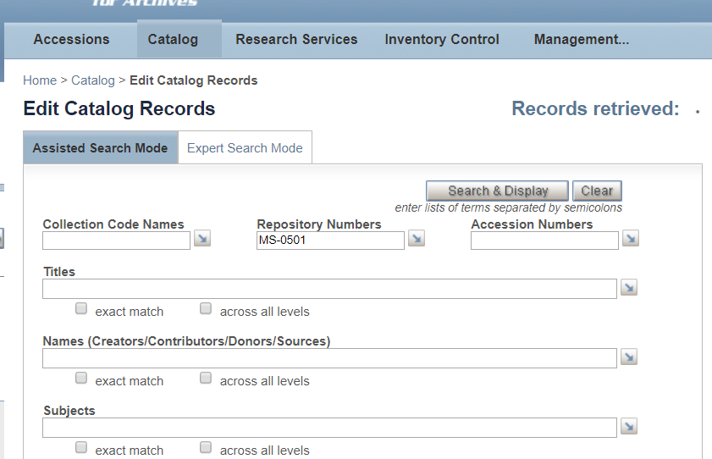

Find the correct collection in the results. Note: make sure you are selecting the top-level record for the collection (not a series or sub-group). The top-level records will begin with the repository number, whereas series or sub-groups indicate that before the number.

For example: Here the first result is a top-level record, and the next two are sub-groups.

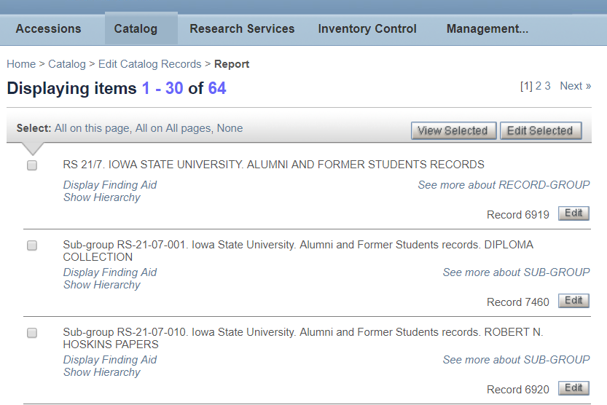

Once you’ve found the correct record, click Edit.

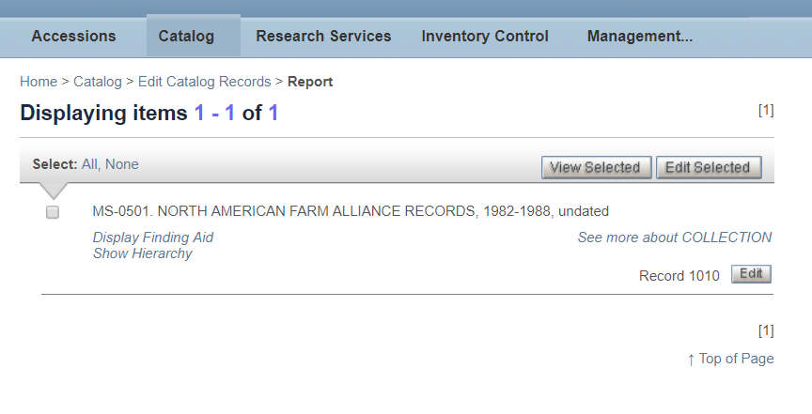

In this window, navigate to the Preferred Citation. This can be done by scrolling down or clicking the field on the left:

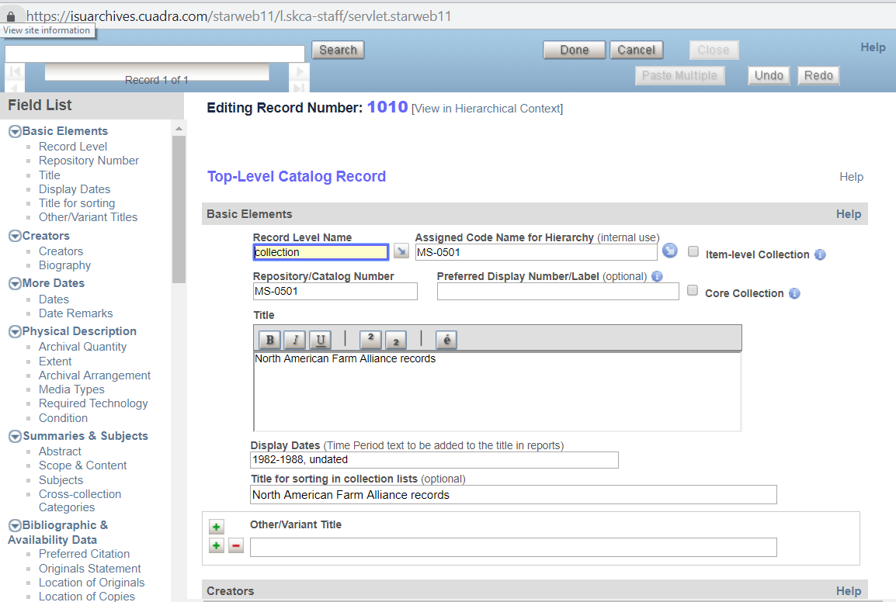

In this box, below the citation, enter the text

“Please use this identifier to cite or link this item: [ARK link]”

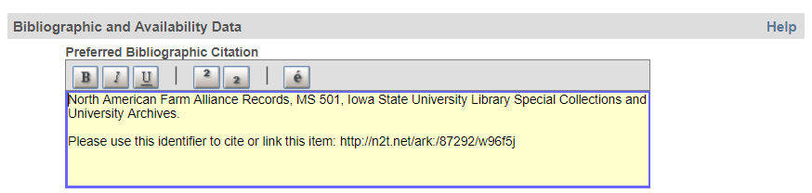

Click “Done” at the top of the window to save the record.

